JAVA ASSIGNMENT 6

1)Write a Java program to create a method that reads a file and throws an exception if the file is not found

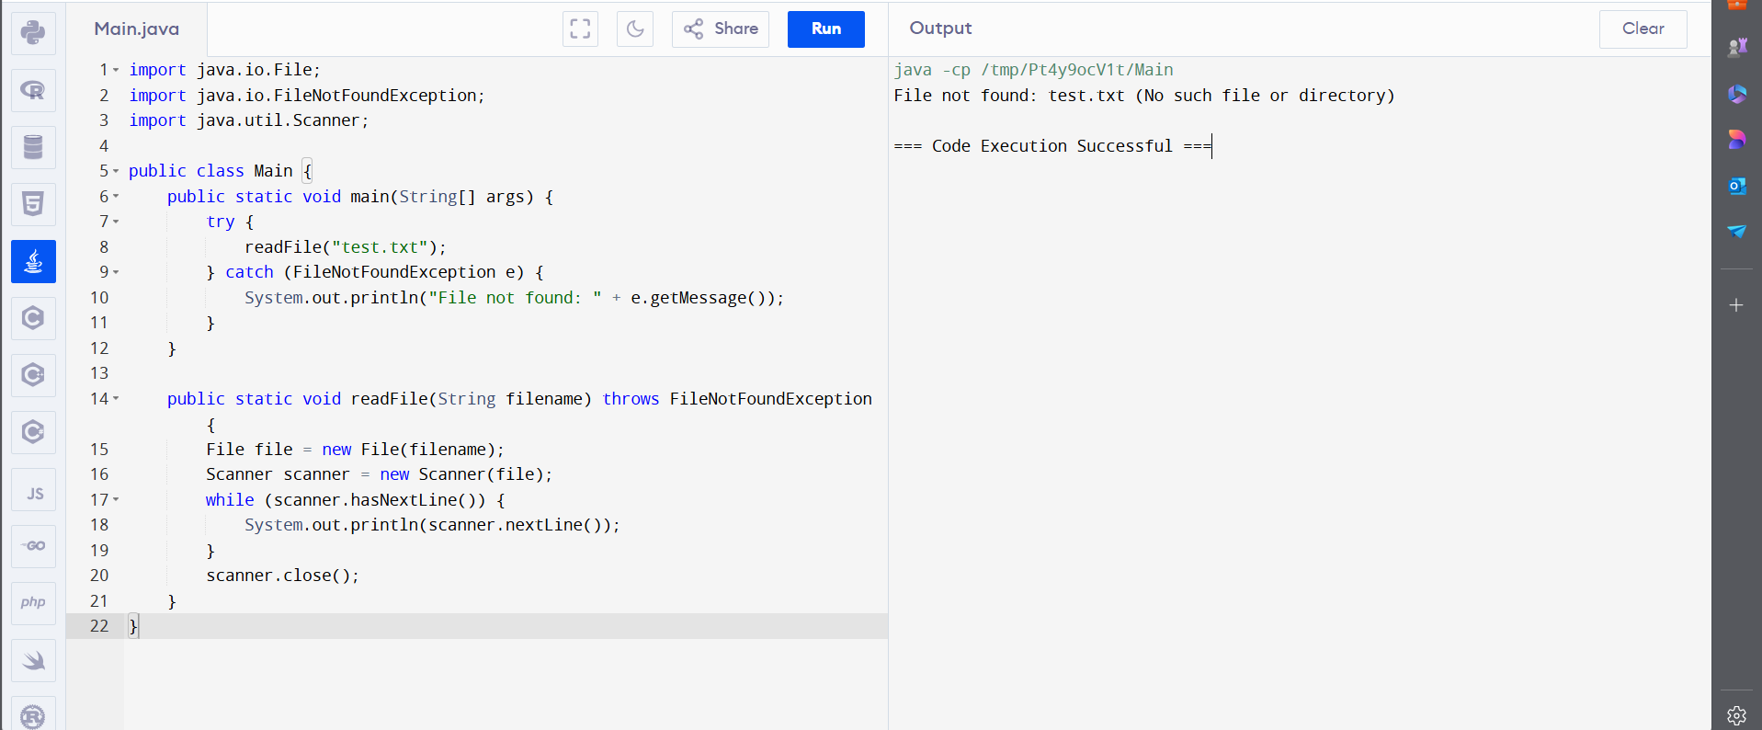

2) Write a Java program to create a class called Student with private instance variables student_id, student_name, and grades. Provide public getter and setter methods to access and modify the student_id and student_name variables. However, provide a method called addGrade() that allows adding a grade to the grades variable while performing additional

Validation.

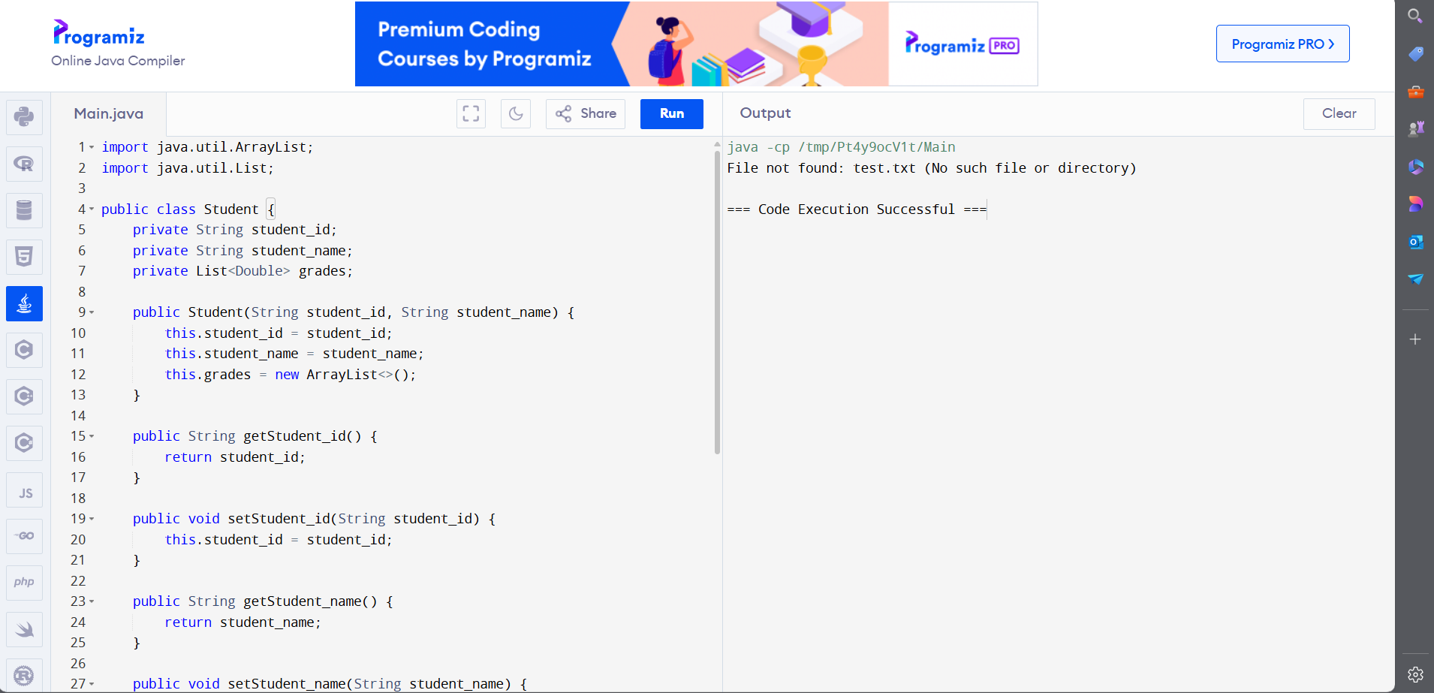

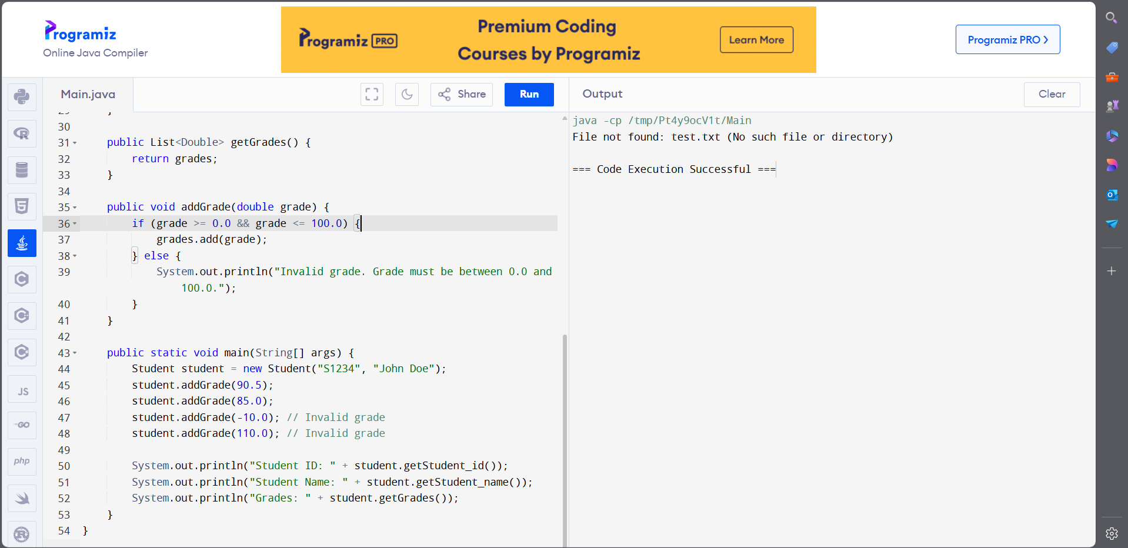

OUTPUT:

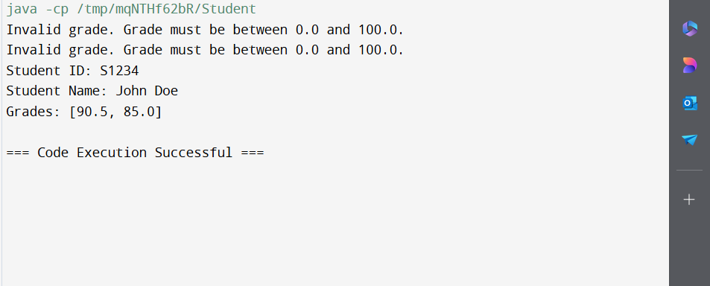

3)Write a JavaFX application with a text input field and a button. When the button is clicked, display the text entered in the input field in a label.

